Sri Venkateswara College of Engineering

Department of Biotechnology

Students’ Biotech Forum

Symposium events

Event name : PAPER AND POSTER PRESENTATION

Rules:

1. The abstract should be brief containing 300 words.
2. The abstracts for paper and poster presentation should be mailed to [omics2k17@gmail.com](mailto:omics2k17@gmail.com) with their team name and title
3. A team of maximum 2 members can participate.
4. Research papers will be selected for the paper presentation and the rest will be selected for the poster presentation.

Topics:

1. Molecular biology
2. Bioprocess/downstream processing
3. Cell biology
4. Bioinformatics and Computational biology
5. Systems biology

Deadline For Submission Of Abstract: 17th September, 2017

Date Of Acceptance: 19th September, 2017.

Organizers: nivethitha srinivaas, prianka.m ( III year )

Contact: 8220865697, 9597318807

Logo:



Event: FORENSICS

Event description:

( Hey, Sherlock!) ( Sherlocked).

How many times you have watched your favourite crime drama and

wondered just how that forensics DNA technology actually works?

It is the theme of the year to evoke the crime investigator within you.

Team : 3 members

Organizer: Shreya Ramesh

Contact: 9841627203



Event: QUIZ

Event description:

Bring those grey cells to the party as Omics 2017 is back with its mind

blowing quiz.

Far from the class room rote, this quiz is going to be a roller coaster ride

into the intense world of techno quizzing.

Team : 2-3 members

Organizer: Hamsikha

Contact: 9445502244

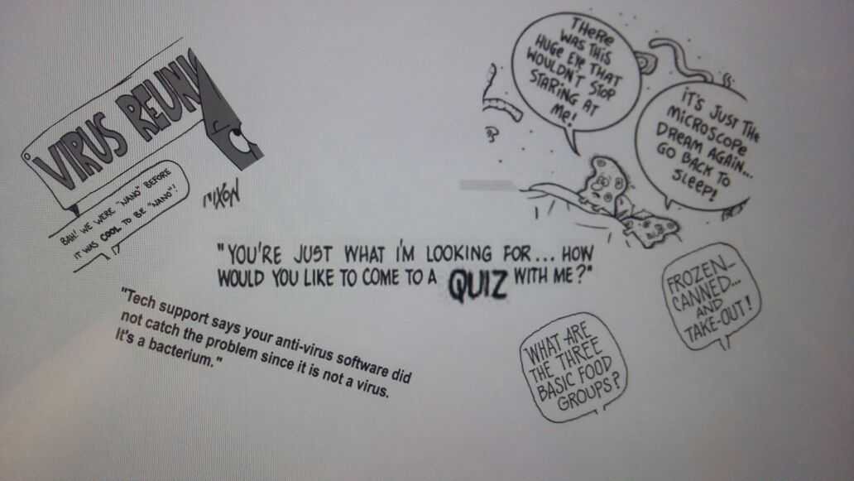

Event: BLOCK N’ TACKLE

Event description:

Every coin has two sides. Want to test your ability to adapt to every situation? Come and witness the fun at omics 2017!

Organizer: Aparna madan

Contact: 8056196416

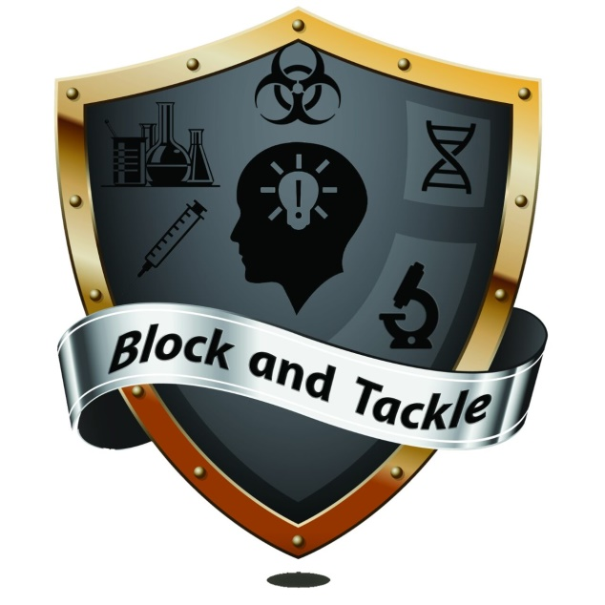

Event: Scatterbrain

Event description:

Wanna go breathless by doing so many stuffs at a time.

Be warned it is quite handful

Boost your power store and get bum fuzzled!

Organizer: Nivyah

Contact:9894792075

